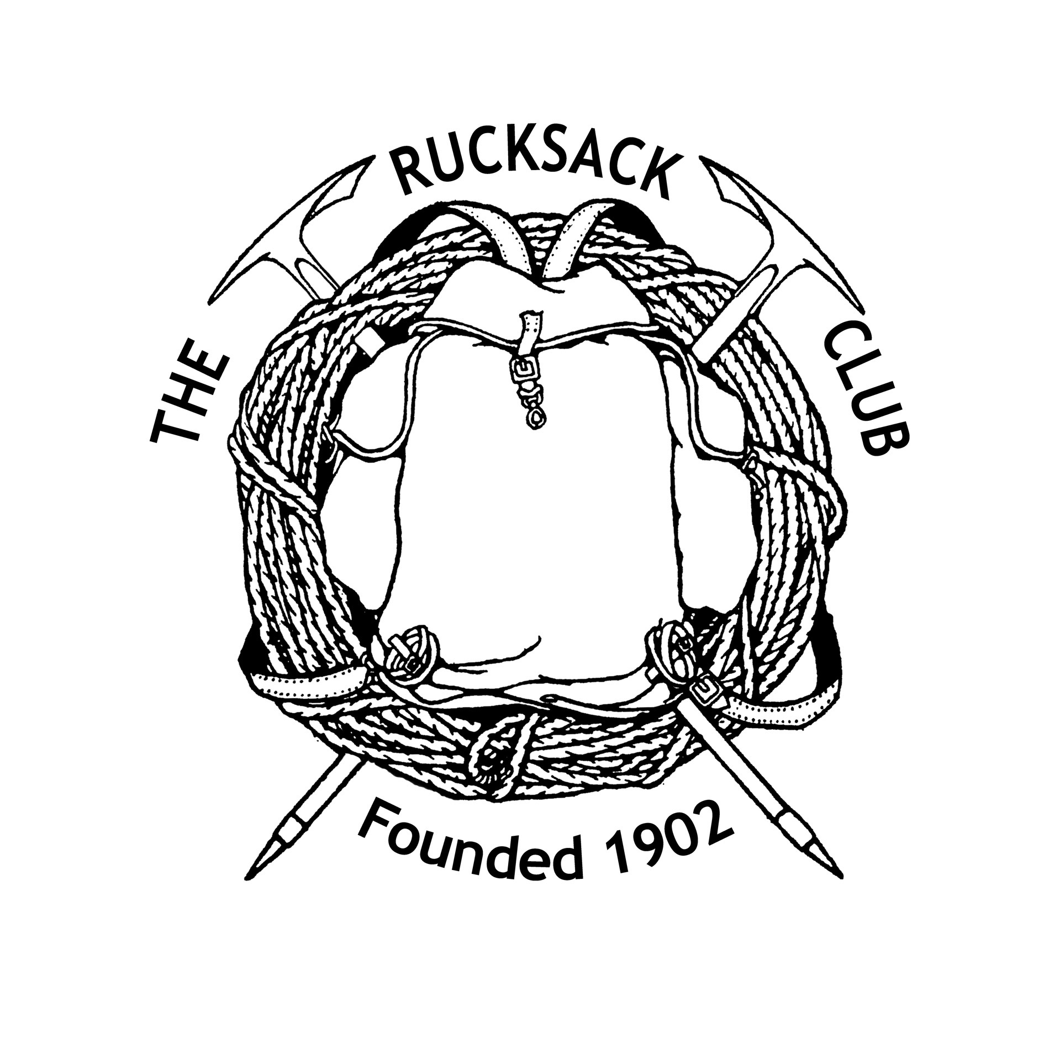

THE RUCKSACK CLUB
APPLICATION FOR ASSOCIATE MEMBERSHIP
If you are interested in joining the Rucksack Club but do not meet the membership requirements (for example knowing two Members to propose and second you) then why not become an Associate Member of the Club? Simply fill in the personal details and subscription mandate and return this form to join@rucksackclub.org. Associate Members receive the Club’s quarterly newsletter Meetstaff by email and may attend Meets on the same terms as Members. You will also become a Club Member of the British Mountaineering Council (BMC), which includes civil liability insurance, and able to access its other services. See www.thebmc.co.uk for details.

The boxes will expand as text is inserted
Prospective Associate Member’s details
Title:
Forename(s)
Informal name
Surname
Address
Post Code
Home phone number
Mobile phone number
Email
Date of birth
BMC Membership number (if applicable).
How did you hear about the Rucksack Club?

Please give the names of any Rucksack Club members that you know.
Mountaineering interests: (optional)
I wish to apply for Associate Membership of the Rucksack Club and if accepted agree to abide by its rules.

Signature:

Date:
Rules relating to Associate Membership:
- An Associate Member will not be entitled to speak or vote at Annual or Extraordinary General Meetings of the Club, own a share in the Club, sit on the Clubs’ committees, have right of access to the Club’s properties (other than when attending Meets or as a guest of a Member), rent a hut key or introduce a guest to a Club Meet without that Meet Leader’s consent.
- Associate Members do not receive the Club Journal or benefit from discounts and special offers specifically negotiated by the Club (though they are eligible for BMC discounts).
- Associate Members will pay a subscription of £21 per calendar year. This sum is used wholly to register and insure them as a Club Member of the BMC. Should they become full Club Members a proportion of the subscription already paid will be discounted from the annual full membership subscription in the year in which they transfer.
- The Rucksack Club welcomes guests on its Meets and sees their presence as a valuable means of recruitment. It is important that they know that Meets are a collective and social activity where, if they involve residence, there are domestic duties all are expected to share.
- If as an Associate Member you wish to bring a guest to a Meet you must ask the Meet organiser who will need basic details – name address and contact details for insurance purposes in the unlikely event of a mishap. Every guest should be known to their sponsor. Recurrent guests should become Associate Members.
- For a full statement of the Club’s Rules and Byelaws see www.rucksackclub.org.
The Rucksack Club is affiliated to the British Mountaineering Council (BMC) which adheres to the following ‘Participation Statement’

“The BMC recognizes that climbing and mountaineering are activities with a danger of personal injury of death. Participants in these activities should be aware of and accept these risks and be responsible for their own actions and involvement”.

In submitting this application you acknowledge this statement.
Personal information:
The Rucksack Club will hold personal information about you in line with its Privacy Statement which can be found on our website: www.rucksackclub.org. Should your application be successful you need to give your permission for the processing of some personal information for specific purposes. Please indicate your permission by deleting “Yes/No” as applicable below:
To comply with Data Protection regulations we need you give you consent/or not to appearing and being identified in the three regular Club’s public means of communication.
Name, address, telephone numbers, email address, for publication in Meetstaff. |  | Y/N
Photos and name published in: | Meetstaff | Y/N
 | Handbook | Y/N
 | Journal | Y/N
 | Website | Y/N

Rucksack Club Subscriptions
All Rucksack Club subscriptions are collected by Direct Debit. We use a BACS service bureau, Fastpay to make the collection but you will see “The Rucksack Club” as the payee on your bank statement. You will be covered by the normal Direct Debit Guarantee (below). Should you become a full Member the mandate you sign and return below will be carried forward.
Collection of all members’ full year’s subscription is normally on 1^{st.} March, or the nearest banking day thereafter, annually. The annual subscription for an Associate Member is £21. The first payment could be less if enrolment is some way into the year. All members will be advised electronically of any change in their individual or the common subscription amounts or dates at least 5 working days before their account is debited.

The Direct Debit Guarantee
This Guarantee is offered by all Banks and Building Societies that accept instructions to pay Direct Debits.

If there are any changes to the amount, date or frequency of your Direct Debit, FastPay Ltd Re The Rucksack Club Limited will notify you at least five working days in advance of your account being debited or as otherwise agreed. If you request FastPay Ltd Re The Rucksack Club Limited to collect a payment, confirmation of the amount and date will be given to you at the time of the request.

If an error is made in the payment of your Direct Debit by FastPay Ltd Re The Rucksack Club Limited or your Bank or Building Society, you are entitled to a full and immediate refund of the amount paid from your bank or building society. If you receive a refund you are not entitled to you must pay it back when FastPay Ltd Re The Rucksack Club Limited asks you to

You can cancel a Direct Debit at any time by simply contacting your Bank or Building Society. Written confirmation may be required. Please also notify us.

Instruction to your Bank or Building Society to pay by Direct Debit
Completed Mandates will be acknowledged.
Name and full postal address of your Bank or Building Society:
The Manager,
Name(s) of Account Holder(s)
Bank or Building Society Account Number
Branch Sort Code |  |  |  |  |  |  |  |  |  |  |  |  |  |  |  |  | - |  |  |  |  |  |  | -
Service User Number |  |  |  |  |  |  |  |  |  |  |  |  |  |  |  |  | 2 |  |  | 8 |  | 5 |  | 1 |  | 6 |  |  | 0
Reference Number – leave blank
Instruction to your Bank or Building Society
Please Pay FastPay Ltd Re The Rucksack Club Limited Direct Debits from the account detailed in this instruction subject to the safeguards assured by the Direct Debit Guarantee.
I understand that this instruction may remain with FastPay Ltd Re The Rucksack Club Limited and, if so details will be passed electronically to my Bank/Building Society.
Signature:
Date:
Banks and Building Societies may not accept Direct Debit instructions for some types of account.
Return this form electronically to: join@rucksackclub.org
The Rucksack Club Ltd. Registered under the Co-operative and Community Benefit Societies Act 2014
Register No 31191 R
January 2023

